***--------------------------------------------------Tomcat and Jenkins----------------------------------------------------------***

**Download Tomcat zip**

https://tomcat.apache.org/download-80.cgi

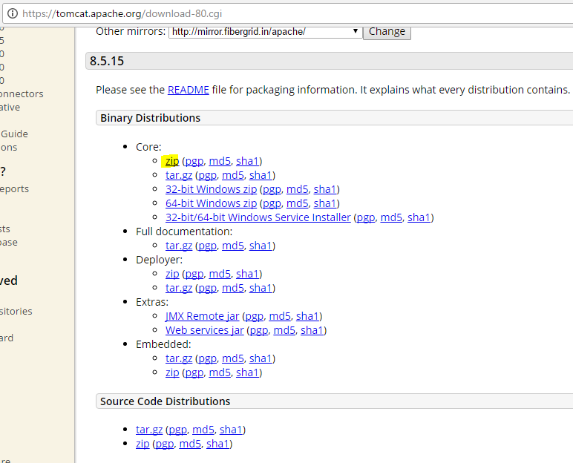

**Download Jenkins.war**

https://updates.jenkins-ci.org/download/war/

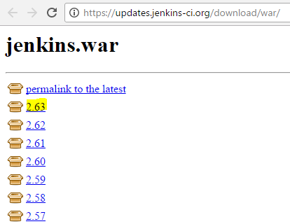

* Download latest war file

Place the War file in tomcat folder eg, path mention in screen shot.

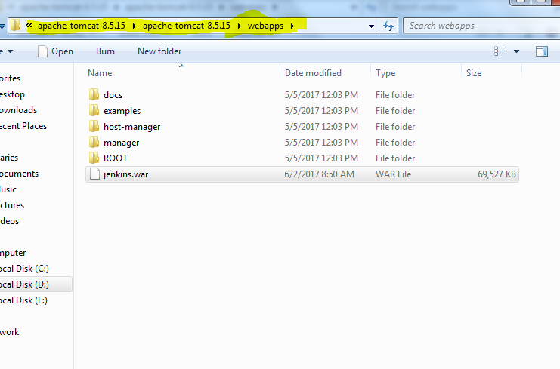

Start the tomcat using start.bat

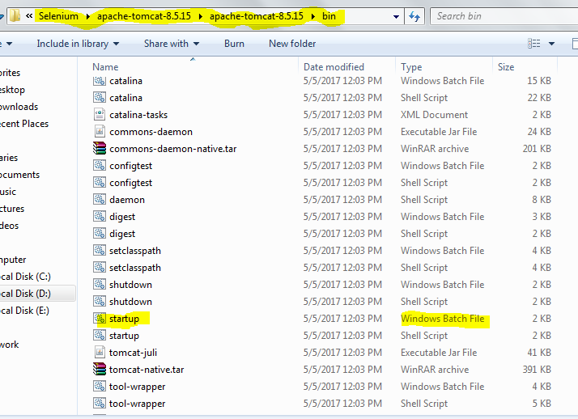

If it does not start then make sure you have JAVA_HOME set in Environment Variable

1. Go to the system option.

2. Set the path and value.

3. Go to the bin folder in tomcat server

4. Click on startup batch file.

* **You should get a message Jenkins fully up and running.**

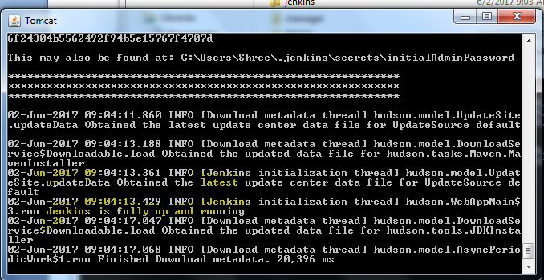

Change the Login Access of Tomcat, so that we can login into Manage App option under ***localhost:8080***

1. Go to the conf folder

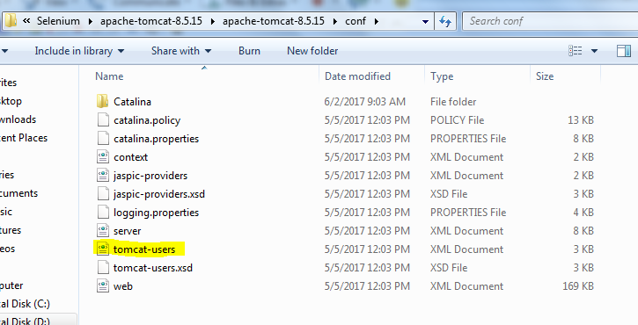

1. Then open tomcat –user file and add below section .

<role rolename="manager-gui"/>

<role rolename="manager-script"/>

<role rolename="manager-jmx"/>

<role rolename="manager-status"/>

<user username="admin" password="admin" roles="manager-gui,manager-script,manager-jmx,manager-status"/>

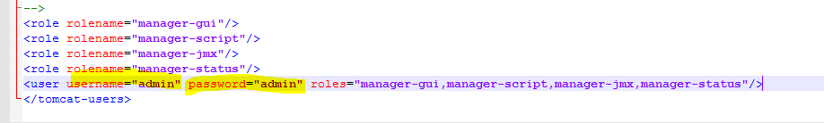

To get the changes done you have to shutdown.bat and then start.bat again

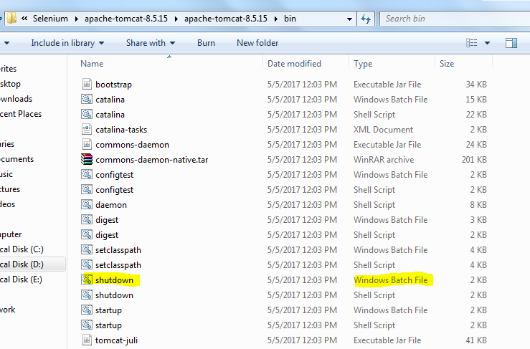

Open any Browser and write localhost:8080->Click Manage App-> Enter the login credentials which you provide

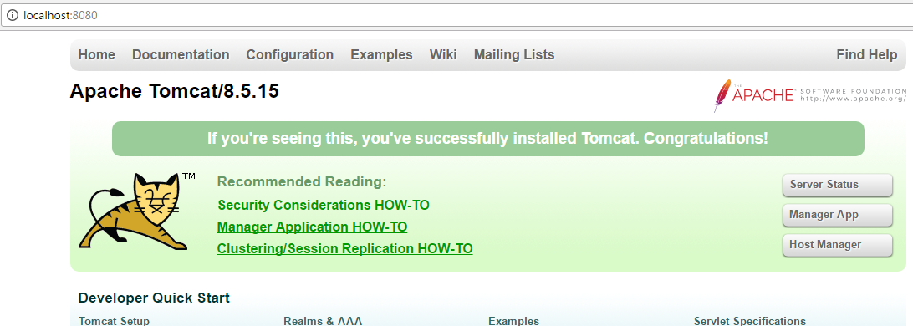

Click on jenkins to get started with Jenkins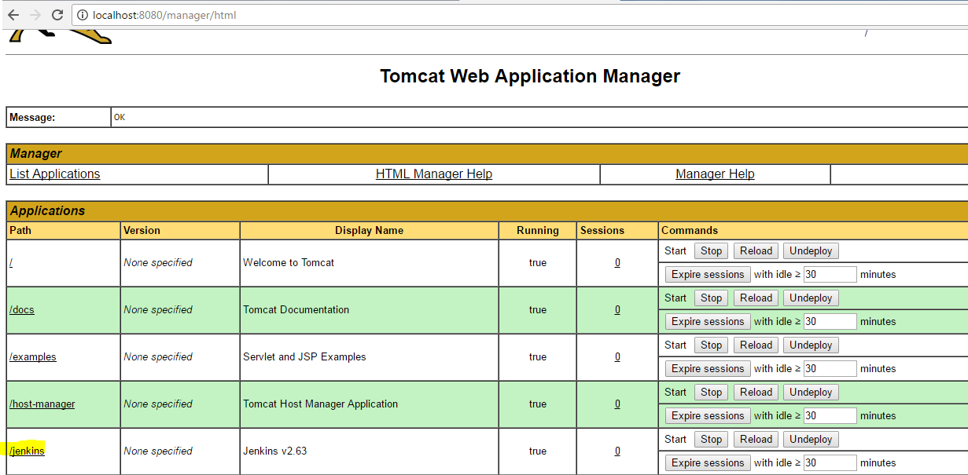

***--------------------------------------------------Jenkins-----------------------------------------------------------***

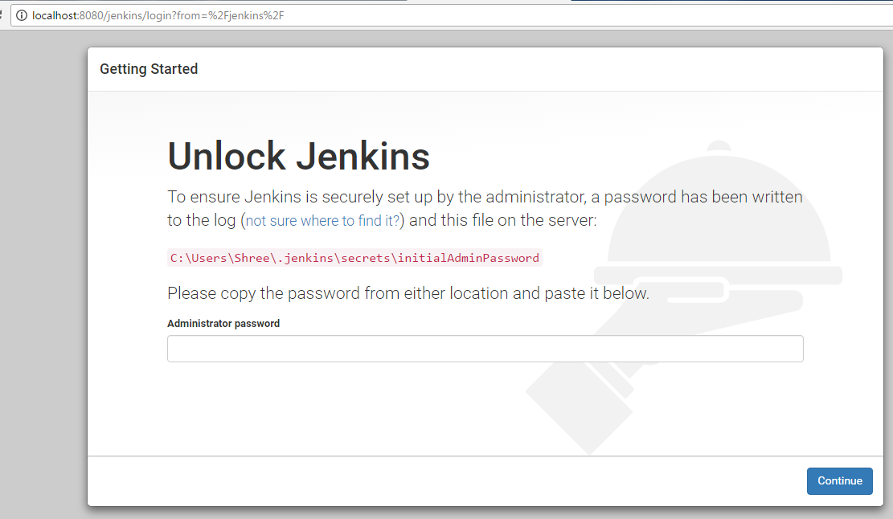

1. Go to the displayed path and copy the password in text box as mentioned on above screen.

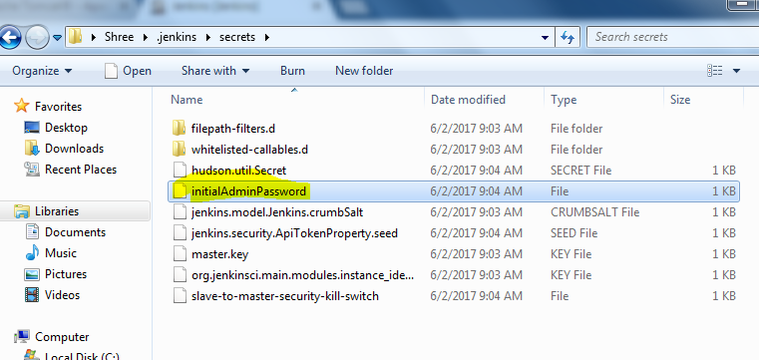

1. Click on Install suggested plugins.

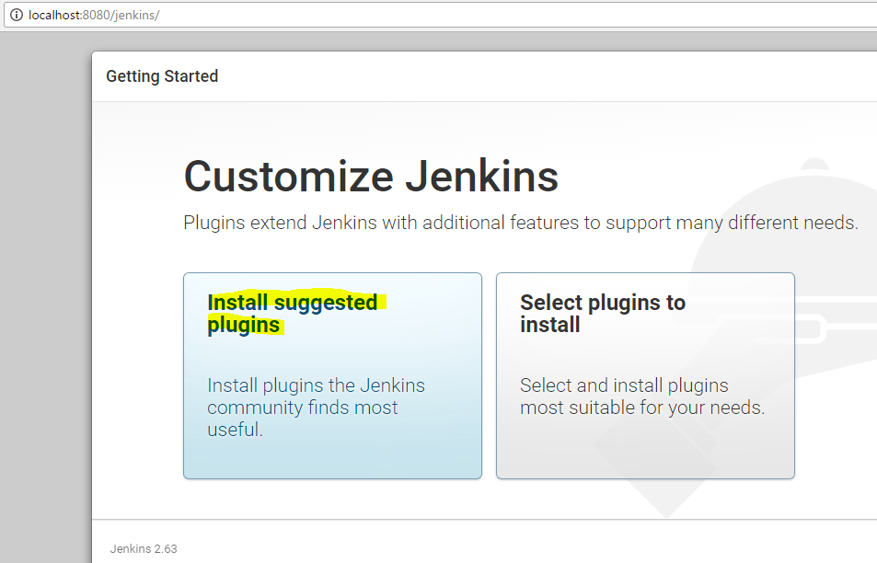

1. Give simple user name & password (which is easy to remember).

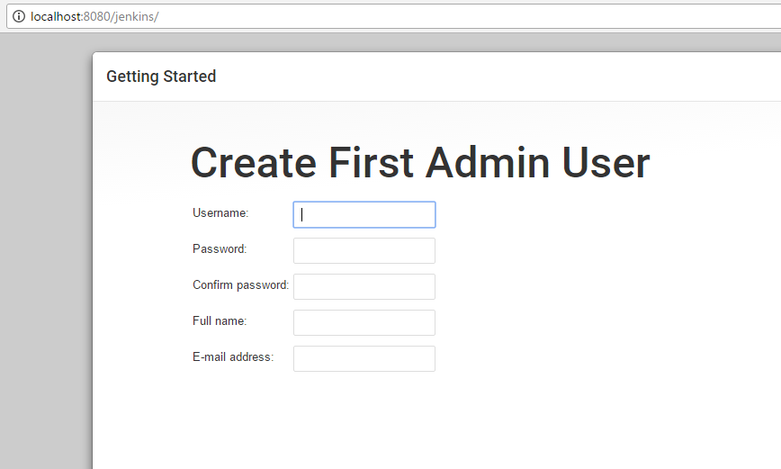

1.Go to the Manage Jenkins option.

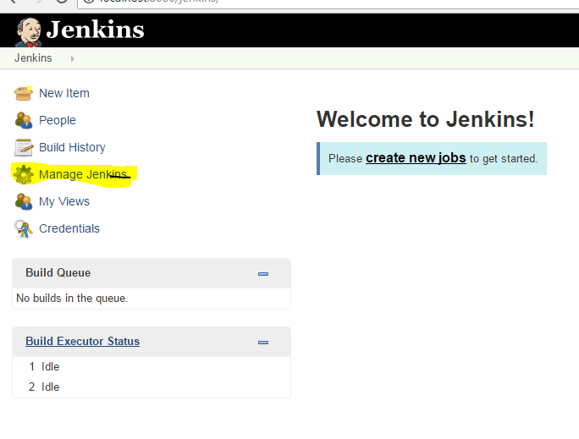

1. Click on Global tool configuration.

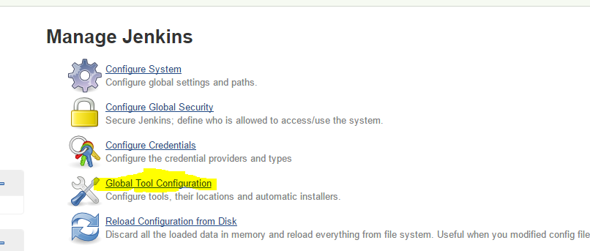

1. Here you have specify the physical path of JDK, Maven, TestNG etc. which is necessary.

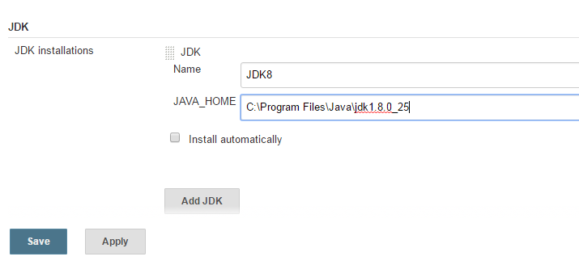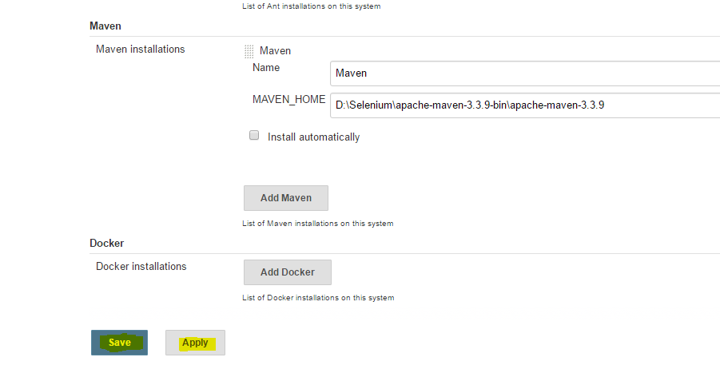

1. Click on Manage plugin and download plugin which is necessary. For e.g. GIT, Maven

